RETAIL COMPANY SALES
First we need to create a role:
USE ROLE ACCOUNTADMIN;
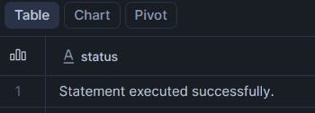

Create a Database:
CREATE DATABASE RETAIL_DB;
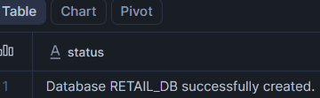

Then we need to create a schema:
CREATE SCHEMA RETAIL_DB.ORDERS_DEMO;
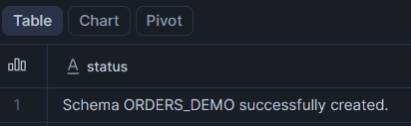

Then we need to create a warehouse and make the size as xsmall:
CREATE WAREHOUSE RETAIL_LOAD_WH
WITH
WAREHOUSE_SIZE = 'XSMALL'
AUTO_SUSPEND = 60
AUTO_RESUME = TRUE;
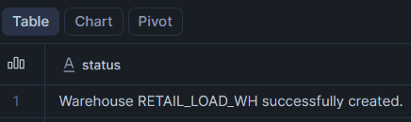

Then we need to create the roles:
CREATE ROLE RETAIL_DATA_ENGINEER_ROLE;
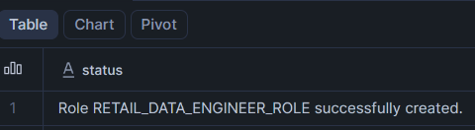

Then we need to create another user named retail engineer user with proper credentials:
CREATE USER RETAIL_ENGINEER_USER
PASSWORD = 'Retail@123'
DEFAULT_WAREHOUSE = RETAIL_LOAD_WH
DEFAULT_ROLE = RETAIL_DATA_ENGINEER_ROLE
MUST_CHANGE_PASSWORD = FALSE;
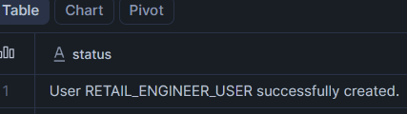

We need to grant access to warehouse, database, and schema for the users:
GRANT USAGE ON WAREHOUSE RETAIL_LOAD_WH
TO ROLE RETAIL_DATA_ENGINEER_ROLE;
GRANT USAGE ON DATABASE RETAIL_DB
TO ROLE RETAIL_DATA_ENGINEER_ROLE;
GRANT USAGE ON SCHEMA RETAIL_DB.ORDERS_DEMO
TO ROLE RETAIL_DATA_ENGINEER_ROLE;
GRANT CREATE TABLE ON SCHEMA RETAIL_DB.ORDERS_DEMO
TO ROLE RETAIL_DATA_ENGINEER_ROLE;
GRANT ROLE RETAIL_DATA_ENGINEER_ROLE
TO USER RETAIL_ENGINEER_USER;
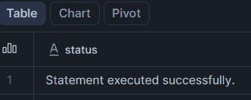

Created a Storage Account and Container name retail-data
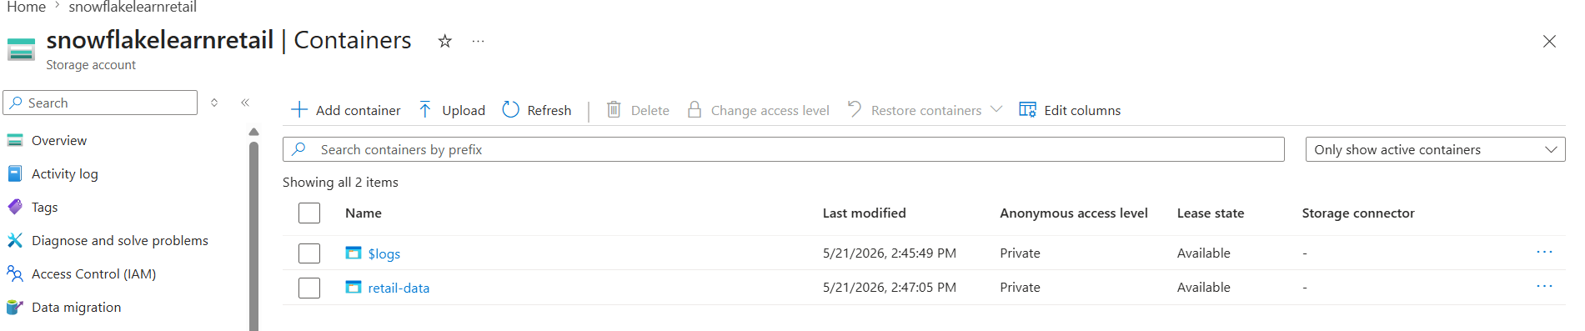

Created raw folder inside that created orders folder
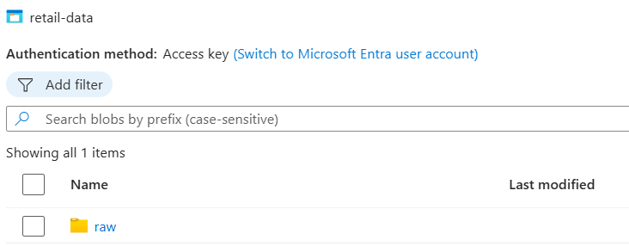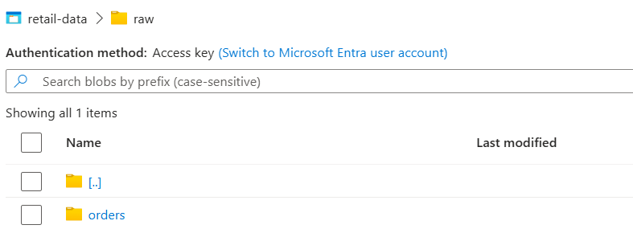

Uploaded a CSV file at orders folder
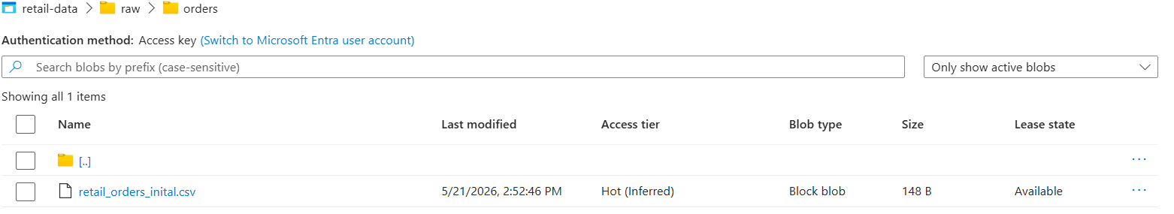
After creating all these we need to use them appropriately:
USE ROLE ACCOUNTADMIN;
USE DATABASE RETAIL_DB;
USE SCHEMA ORDERS_DEMO;


CREATE OR REPLACE FILE FORMAT RETAIL_CSV_FORMAT
TYPE = CSV
SKIP_HEADER = 1
FIELD_OPTIONALLY_ENCLOSED_BY = '"';
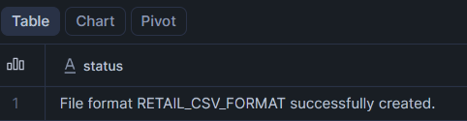

We are integrating the azure account with the tenant id:
CREATE OR REPLACE STORAGE INTEGRATION RETAIL_AZURE_INT
TYPE = EXTERNAL_STAGE
STORAGE_PROVIDER = AZURE
ENABLED = TRUE
AZURE_TENANT_ID = '65087c47-0017-4258-8086-72832006d566'
STORAGE_ALLOWED_LOCATIONS = (
'azure://snowflakelearnretail.blob.core.windows.net/retail-data'
);
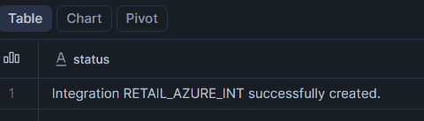
DESC INTEGRATION RETAIL_AZURE_INT;
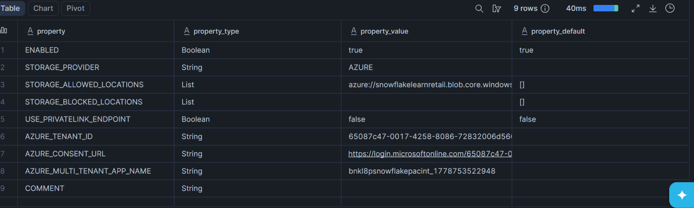

We need generate copy the blob SAS url and then container url also:
CREATE OR REPLACE STAGE RETAIL_AZURE_STAGE
URL = 'azure://snowflakelearnretail.blob.core.windows.net/retail-data/raw/orders/'
CREDENTIALS = (
AZURE_SAS_TOKEN='?sv=2026-02-06&ss=bfqt&srt=co&sp=rwdlacupiytfx&se=2026-05-21T17:46:58Z&st=2026-05-21T09:31:58Z&spr=https&sig=9LMtaMsJcwFKcQk4ebXB00DoOc%2FLM7U9d2ZY14w92tI%3D'
)
FILE_FORMAT = RETAIL_CSV_FORMAT;
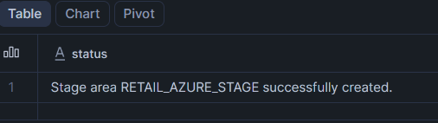

Then the csv file will be visible
LIST @RETAIL_AZURE_STAGE;
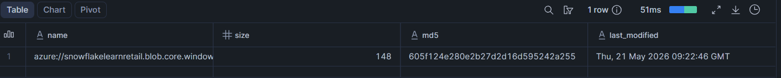

Then we need to create a table orders_raw and orders_final
CREATE OR REPLACE TABLE ORDERS_RAW (
ORDER_ID NUMBER,
CUSTOMER_NAME STRING,
PRODUCT STRING,
AMOUNT NUMBER,
ORDER_DATE DATE
);
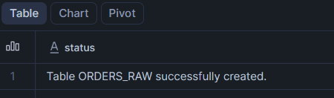

CREATE OR REPLACE TABLE ORDERS_FINAL (
ORDER_ID NUMBER,
CUSTOMER_NAME STRING,
PRODUCT STRING,
AMOUNT NUMBER,
ORDER_DATE DATE
);
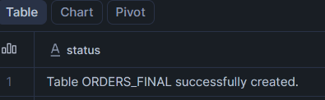

We have to load the data into two tables present in the CSV file and verify the output:
COPY INTO ORDERS_RAW
FROM @RETAIL_AZURE_STAGE
FILE_FORMAT = (FORMAT_NAME = RETAIL_CSV_FORMAT);
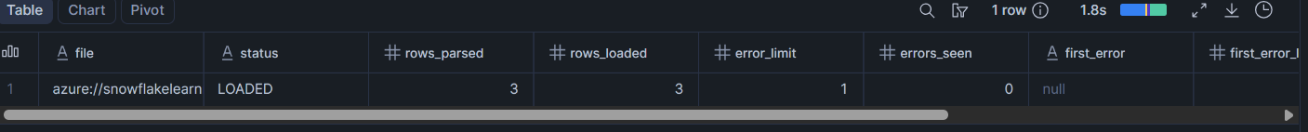

SELECT * FROM ORDERS_RAW;
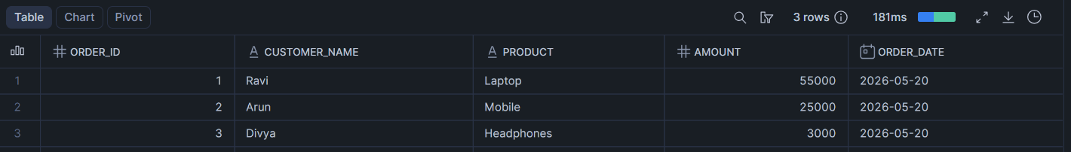

INSERT INTO ORDERS_FINAL
SELECT * FROM ORDERS_RAW;

SELECT * FROM ORDERS_FINAL;
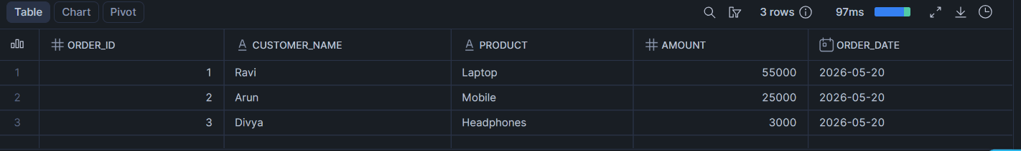
Then we need to create a pipe:
CREATE OR REPLACE PIPE RETAIL_ORDERS_PIPE
AUTO_INGEST = FALSE
AS
COPY INTO ORDERS_RAW
FROM @RETAIL_AZURE_STAGE
FILE_FORMAT = (FORMAT_NAME = RETAIL_CSV_FORMAT);
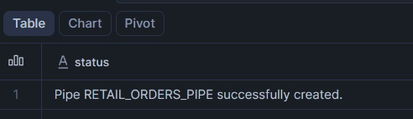

Creating a stream which tracks newly inserted rows in ORDERS_RAW:
CREATE OR REPLACE STREAM ORDERS_RAW_STREAM
ON TABLE ORDERS_RAW;
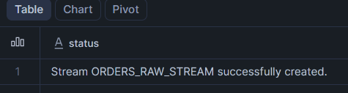

Create Task for Incremental merge to prevent from duplicate data
This task will:
- Read only new rows from the stream
- Insert only new ORDER_IDs into final table
- Prevent duplicates
CREATE OR REPLACE TASK ORDERS_MERGE_TASK
WAREHOUSE = RETAIL_LOAD_WH
SCHEDULE = '1 MINUTE'
AS
MERGE INTO ORDERS_FINAL T
USING (
SELECT * FROM ORDERS_RAW_STREAM
) S
ON T.ORDER_ID = S.ORDER_ID

WHEN NOT MATCHED THEN
INSERT (
ORDER_ID,
CUSTOMER_NAME,
PRODUCT,
AMOUNT,
ORDER_DATE
)
VALUES (
S.ORDER_ID,
S.CUSTOMER_NAME,
S.PRODUCT,
S.AMOUNT,
S.ORDER_DATE
);
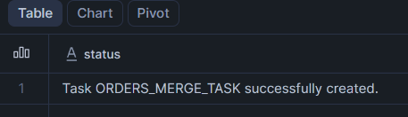

ALTER TASK ORDERS_MERGE_TASK RESUME;
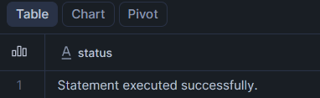

After this process Create a CSV file named retail_orders_incremental_20260521.csv and upload it into the raw/orders folder present in the container
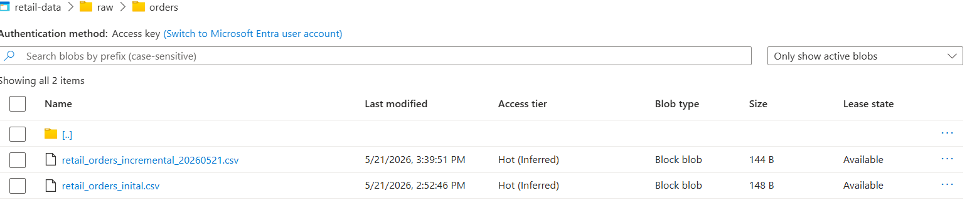

Since AUTO_INGEST is disabled, we manually refresh the pipe.
ALTER PIPE RETAIL_ORDERS_PIPE REFRESH;
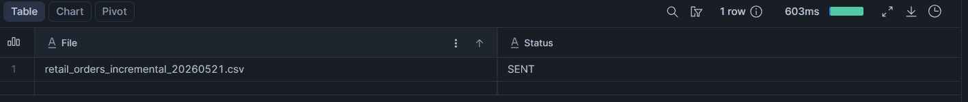
SELECT * FROM ORDERS_RAW;
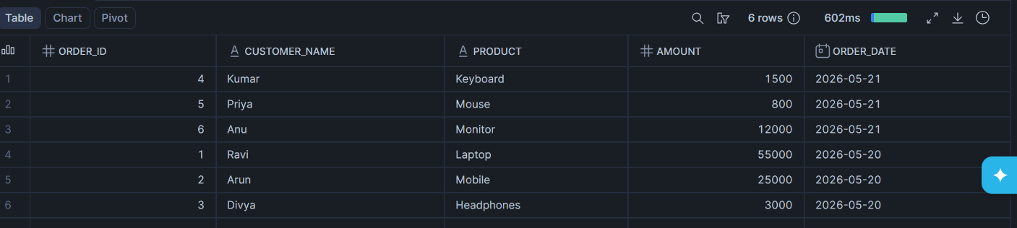

SELECT * FROM ORDERS_FINAL
ORDER BY ORDER_ID;
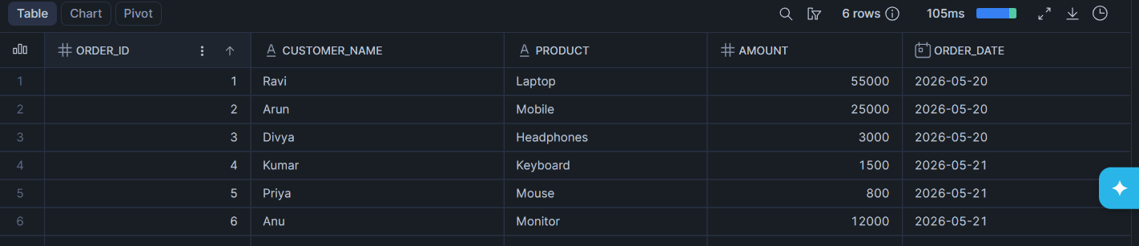

SELECT COUNT(*) FROM ORDERS_FINAL;

SELECT * FROM RETAIL_DB.ORDERS_DEMO.ORDERS_RAW_STREAM;
